Operation and Fixing of the Button Machine S-200
https://jillclarke.com.au/button/Operation_and_Fixing_ the_ Button_ Machine_S.docx
ABC2000 is the company we buy blanks from, and who could fix the machine.
https://www.badgemachine.com.au/index.html
https://www.abc2000.com.au/shop/badge-makers-and-supplies
https://www.abc2000.com.au/shop/index.php?route=product/search&search=58mm
https://www.abc2000.com.au/shop/index.php?route=product/search&search=44mm

Jammed Die
- Turn the whole machine upside down. One person steady the machine, balance on its handle, the second person, tap gently around the die to release.

Changing over die
Remove
First remove slide plate on the bottom by lifting the top section up and sliding through.
1 Push the bottom as far left as it goes, 2 Lift the top mechanism to be above metal stoppers, 3 slide through.
The remove the top, wiggle the top die out.
(Note, the hex key is only used for servicing and is not required for swapping the die)
Add
1 Line up the lug with the grove in the top rod and click in.
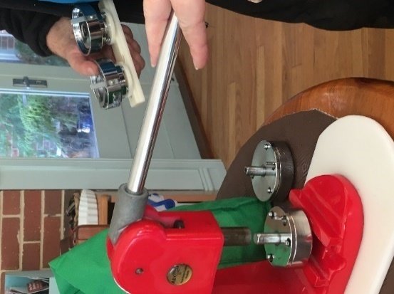
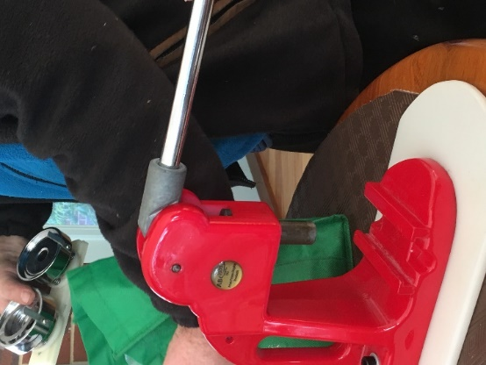

2. Now you are reversing the removal of the sliding part – hold the top part up out of the way, and slide through.

Using the button machine
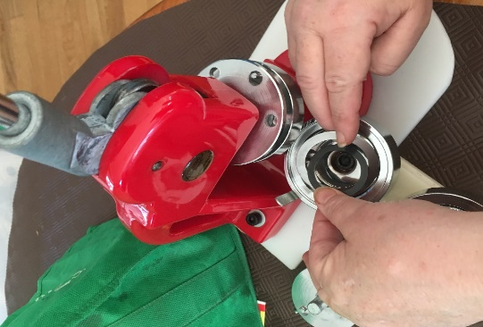
Overview - https://criesofvalhalla.com/badge-maker-instructions-s-type/
O Ring
When using 58mm Metal blanks, Metal O ring is added to the RHS.
For the 44mm, the plastic black O ring is added to the RHS.
Other weird plastic stuff do not use any O ring – or seek online videos for exact instructions.
Template for design
https://jillclarke.com.au/button/Blank_Button44mm.docx
https://jillclarke.com.au/button/Blank_Button58mm.doc
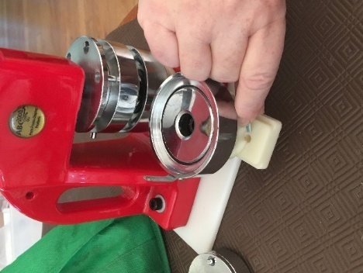
Working on the Left side, TOP
- load metal blank face up,
- design face up aligned straight,
- lastly Mylar and press the lever to take up the front set into the top of the machine.
PIN Bottom, right side
The Pin is in the machine Upside down – you can’t see the pin..
The base is put in at a slight angle (58mm red mark, 44mm black mark) as our machine rolls the base pin to the right as it melds the two pieces.
Slide the base with the loaded pin base and press until you feel it join.
Things that cause Malfunction
LHS top
- wrong sized paper, (it must sit flat, and cover the blank)
- accidently 2 Mylar covers
- accidently two metal blanks
- metal blank not placed level
- The Three Lugs, as you press not lining up correctly – left lug under, middle lug through, right lug under
RHS Base
- pin base in incorrectly – wrong side up
- pin base in incorrectly – not level

